Hi family, September 8, 2021
Below is a summary of our trip to the Grand Canyon to do river rafting through its might white water. Hope you can enjoy our experience.
We had been excited about this trip for over a year when we reserved our spot on this trip. We read all the information as it was sent to us via email. We purchased a few supplies like water shoes, some rain wear pants (which we never used), Ellen got a new swim suit consisting of a swim skirt with a sun proof, long sleeve top. I got a pair of gloves for holding on to the J-rig raft’s ropes or belts, sunscreen, insect repellant, etc. Everything had to go into a soft sided small duffel bag. These bags were to be placed inside a waterproof duffle bag that also held our sleeping bag (which we also did not use) but we did use a provided sheet and a fleece blanket that was also to go inside this bag. It was important that we bring a water bottle and were severely instructed to stay hydrated.
First day, 28th Saturday. Katie drove us to the airport picking us up at 4:30 AM for our 6:00 flight. It was a full flight and everyone of course wore masks. It was a 3 hour flight. A Lyft driver picked us up for the 10 minute drive to the nice Marriott hotel in Las Vegas. It was early enough to settle into the room then met some of the fellow rafters, the Kauffman’s, friends of our son Paul. At 2:00PM we motor bused via a nice coach to Hoover Dam for an excellent tour of the history, structure and its building. The water behind the dam was down some 158 feet this year. The whole area is suffering from a 20 year drought. It seemed impossible for such a large river to dry up that has a water shed area of some 244,000 square miles, 1/12 of the area of the lower 48 states. Although the river begins in the Rocky Mountains, most of its length drains the arid Southwest region. The stories of how the Hoover Dam came about is a whole ‘book’. But we would be glad to share if you want more information.
Our next evet was to drive around the side of Lake Mead (behind Hoover Dam) and go for a dinner boat ride. It was cooling off time but the air-conditioned areas were most appreciated. The food was excellent and we continue to get acquainted with our other 18 rafters, four of them older than us. We had a family from Kentucky, a 77 year old grandmother who brought her two grandsons and daughter in law. Another couple a few years older than us was from Colorado, and a former IBM guy/college professor. A medical doctor and a nurse practitioner was from N.C. as well as a pilot. So we had most interesting conversation during our ride down the brown red waters of the Colorado. We slept well that night since we had gotten up at 3AM to begin this long day.
Second day the 29th of Aug. Sunday morning we grabbed our hot sandwich box breakfast and was on a bus to the small Boulder City Airport Terminal. It took two flights to get all in small planes that only had 10 passenger seats for the 45 minute flight across to the north side of the canyon to the Bar 10 Ranch tiny airstrip. The kids there feed us a good sandwich lunch before they entertained us with a short horseback ride, Arizona pioneer history, some skeet shooting and other activities. This part of the ‘Arizona Strip’ north of the Canyon and south of the Utah state line has quite the history STILL of being rather ‘outside the law’. The stew beef supper was from their own cattle and they were generous with the side dishes. We then chose to watch a video of all the river people from history that tried to tame the white water. Good preparations for tomorrow’s appreciation of the seasoned river captain and his two person crew that would introduce us to the river life. We had several sleeping choices, but picked one inside the ranch house that had a bathroom not so far away. Most of the folks that work at the Bar 10 drive there from St. George, Utah. That is a 70 mile trip over a non-paved road going straight south, about 3 hours each way. They fixed us a hardy breakfast the next morning before we put everything back in our duffel bag.
Third day, 30th Monday the next ride was in a seven seater helicopter. They weighted us and our bag, put us through their balancing formula and assigned us our seat for our leap over the north rim. And I got to ride the 10 miles in the front seat with the pilot. He said he had worked his way up from the horse wrangler/coral cleaner, but later we found out he was retired from the military. These little aerial rides were like living in past dreams when we can fly from mountain top, across gullies, glide sideways into a curve and do a soft land where there looks to be no place to land. It is a dry and dusty area with hardly any trees but lots of little shrubs, cacti and sturdy grasses, yuccas, tamaris trees. The land is raw from when the rains do come, but since the current drought everything that doesn’t have long roots has turned grey, black, white or that earthy color. The circles from water holes may have had a few green circles, but it was not a good time to be even a mountain goat. Dropping about 2000 feet to the Whitmore Wash landing on a square the size of a living room rug made us glad for our pilot’s perfectionist skills. The walls of the canyon are so unique in every spot. The only reason helicopter are allowed here was because the Indians owned that side of the river. Otherwise the National Park doesn’t allow any other flying vehicles in the Canyon. By the way the return trip for the helicopter took a group out of the canyon after their 7 day adventure on the upper/northeastern part of the river.
After two or three helicopter flights to get our whole group river side we got instructions for our gear. This river mile spot was at mile188. We would travel to mile 277 at Pearce Ferry before we left the river, which is only 89 river miles. Western River Expeditions were the best for their organization, skill, experience and knowing how to make our trip memorial. On arrival at the Whitmore wash this was the point we received the two waterproof bags. One was big enough for our one small duffels that were only allowed. We stuffed it inside on top of their provided sleeping bag, which no one used because it would have been too hot on our trip, but you could use it as padding. They also gave us a twin sheet and a fleece blanket. The second bag they gave us was called the day-bag for things that we might need during the ride. The big bag was stowed on top of the J-rig, covered with another tarp and lashed down with strong bungee cords. The J-rig as you can see in the picture is 5 big pontoons connected by ropes with a frame over the top for provisions. We then clipped our water bottles and our day bags to these cords. We rode about a dozen rapids that soaked us completely and the raft. The front riders would sit straddle the three inside pontoons. The side pontoons were too dangerous as they bounce off the large river boulders in the rapids. Hold on for Kolb and Mile 209 Rapids that were our initiation to the 54 degree water! We were surrounded by soul-stirring scenery observing land out of a time. Breathtaking canyon walls shoot skyward in a dramatic display of geologic history as we experience the fingers of God as HE formed this post-flood water ditch. Sandstone cliffs conjure up imaginary shapes in different colors and dimensions. We could find faces from the past in the sculptures.
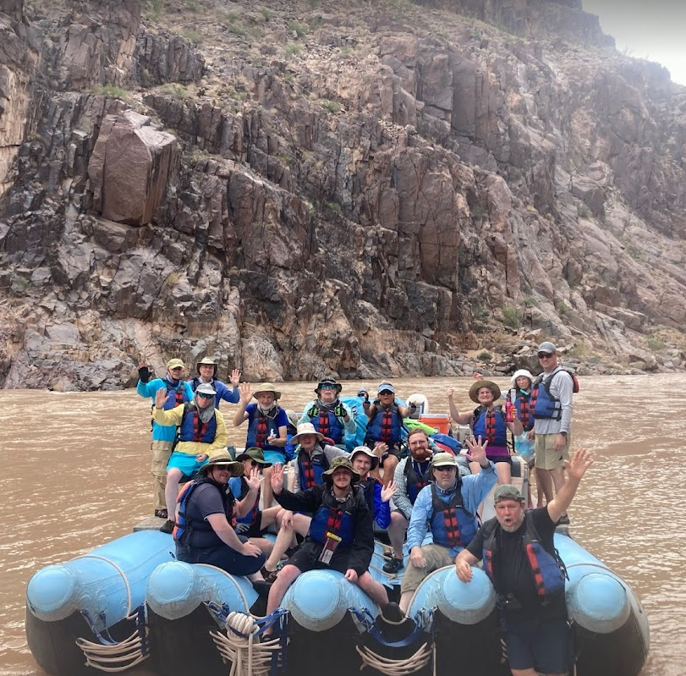
Jim was one of the nine that could sit up front, at least part of the trip. It was a strain on ones legs and back after a while. I sat right behind him on some of the storage coolers that were covered with padding and strapped down. There were either ropes or straps to hang on as we went through the rapids because the rapids were violent enough to throw one off if you didn’t hang on. We got good instructions as to what to do if in the unexpected event you did leave the boat. Our captain was VERY experienced and would pull over to the side sandbars to give us plenty of ‘pit’ stops. Our International Creation Ministries geologist, Dr. Clearly also took these as teaching opportunities and show us the Great Unconformity, possibly Day 3 creation of dry land, and explains other sedimentary rocks layer. He said even the Vishnu Schist (this very bottom of the earth’s mantle before the flood had been victim of the earth’s heating, expanding, cooling and bending.
Genesis 7:11 In the six hundredth year of Noah's life, in the second month, on the seventeenth day of the month, on that day all the fountains of the great deep burst forth, and the windows of the heavens were opened.
How this layer had then been sheared off in the initial early part of the flood, then layer upon layers of sediments waxed back and forth in the following days of the peaking of the flood and subsequent time of the waters receding. I was addicted to the eye color candy: orange, red, pink, mauve, black with purple lines, greys and whites. So many new geology terms: 1) Metamorphic basement rocks, 2) The Precambrian Grand Canyon Super group, and 3) Paleozoic strata. Then there are the layer’s named: from top (rim) to bottom (river):
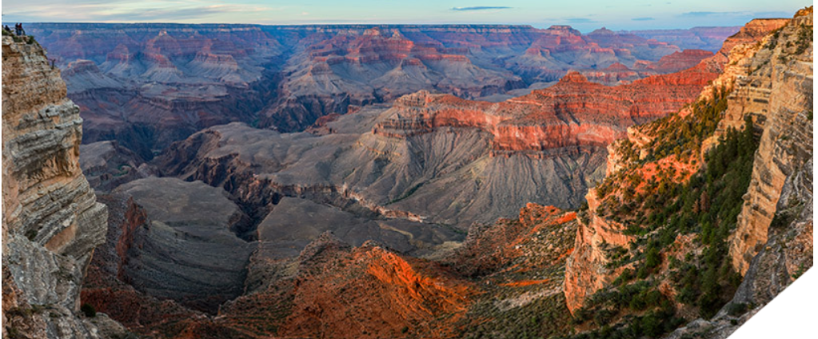
Kaibab Limestone
Toroweap Limestone
Coconino Sandstone
Hermit Shale
Supai Group (a mix of sandstones, shales, and limestones)
Redwall Limestone
Muav Limestone
Bright Angel Shale
Tapeats Sandstone
Vishnu Schist
First night camping on the river side was not boring. We got issued our sleeping cots and tents if we wanted them. Most didn’t want a tent as sleeping in the open helped with the heat. But of course we were lucky to get evening showers and night sprinkles!! We sat under a plastic tarp the first shower before dinner. The dinner was wonderful as nothing keeps campers happier than to have a good meal. They had appetizers of chicken wings and chips, then a good salad and spaghetti, garlic bread for the main course and cheese cake for dessert. We ate off plates and had real forks and spoons, which we were then responsible to wash and keep track of our own (Covid-prodigals). Jim and I had our own little camp spot and as it was close to the river, all noise was drown out. We pulled the tarp over us when the rain began again in the night. It was hard to fall asleep but eventually dreamland gave way over the cares of the day.
Aug. 31th, Tuesday was our best rapids day. Our J-Rig rafts enter awesome Lower Granite Gorge with a series of moderate rapids including Granite Spring, Diamond Creek and Travertine. We took some time to hike, explore and play at Travertine Grotto, a fantasy of a series of hidden waterfalls and pools. The J-rig ran the biggest rapids of the trip, the “230’s.” This was the best day as we were ‘seasoned’ river buddies and knew what to expect and was expected of us. I felt like I knew how the disciples felt when they called out to Jesus, “help we are drowning.” Up and down riding a wild bronco was reason for me to squeal louder than I should have with each soaking. The very warm temperatures would dry us out in quickly.
We saw other smaller round pontoon rafters with about 3 people per boat on the river. Their river guides looked mature and capable with long paddles and talented arms to know how to get thru the white water that challenged reason to be assaulted. It takes about two weeks to row yourself through the canyon. At one point we passed them and were ahead, then we collected some supplies in the river from possible turned over boats. We left them on the side of the river so they could collect them as they would eventually pass. Even spilled boats have prodigals in this wilderness.
Tuesday’s evening meal was delicious, shrimp appetizers and New York strip steak grilled on charcoal, with chocolate brownies for dessert. It was good conversations with like-minded friends about current trends in the country and personal faith, the mercy in the watery judgement causing the canyon. Then here is the judgement that is merciful to counsel, warn and guide us of our current situation before:
Revelation 8:7 The first sounded, and there came hail and fire, mixed with blood, and they were thrown to the earth; and a third of the earth was burned up, and a third of the trees were burned up, and all the green grass was burned up.
We did chose to get a tent this night and was not disappointed in our decision. It was a bit warm at first, but when the rain came and cooled things off we sleep sound without thinking about our duffels getting all wet. But even our swim wear that was hung up on some tamarisks bushes still dried after the rain stopped. The raft got unloaded and loaded with team lined up to form conveyor belt transfers. The smart light- packers were appreciated, the heaver packers’ bags were a drag. We had chairs and tents and the kitchen supplies that got delivered to the campsite and the reverse of things the next morning for strapping down in specific spots on the boat. Only after everything was stowed would the journey continue, absolutely NOTHING was left for even the crows.
Fourth day, September 1, after our egg, sausage and blueberry pancake breakfast we stowed our camping equipment but separated our duffels from the outfitters supplies. We kept our lifejackets on but boarded our J-rigs for the last time. As we neared Lake Mead, the river calms and the canyon widens. We savored our final morning in Grand Canyon as we head down river for about two hours. At times the captain cut his motor and we drifted in reverent silence. We were ahead of schedule! Transferring off our J-rig was a little sad saying good bye to a great three days. We and another crew of some 16 boarded a passenger boat that held about 30 rafters that would quickly get us to mile 277 before Pearce Ferry. At this time there is an unpassable rapid beyond Pearce Ferry. The transfer at the up side of Lake Mead took us to where two shuttle buses returned us to Las Vegas via highway 93, Interstate 11, and 215. The first was for the dirt road with some pot holes and the second was nicer for the smooth paved highway, probably another 2.5 hours. We travel by way of the recently completed Mike O’Callaghan–Pat Tillman Memorial Bridge that spanned the canyon over the views of the Hoover Dam. I enjoyed seeing the dessert’s cacti, Joshua Tree Forest and the rest of the way Nevada residents live. I liked the motto that is good for campers everywhere: “make no assumptions, expect surprises”.
The last night in Nevada, I don’t even like saying Las Vegas!!, was wonderful. Nothing like a good bath after three days in the red sandy waters of the Colorado River. We went to bed early as we had another early flight the next day. It is against the law to carry any rocks out of the canyon, but we had enough sand in our shoes to stop up a sink drain. Before I washed them I let them dry and shook out about ½ cup from both Jim and my water shoes. I thought I had lost my camera the last day. Everyone had their phones or cameras in waterproof cases attached to a lanyard around our neck. Of course they would get in the way when doing the conveyor belt duffel shuffle, so I thought I had slung mine around on my back and it must have broken. But as I was confessing to Jim that I lost our pictures he said he had my camera. It was such a relief. I didn’t know which I was saved most from, the loss of the pictures or Jim’s disappointment that I couldn’t keep up with the equipment. Anyway he was my hero and we now have pictures to share with you. We will bring them when we see you next!!
Love, Ellen & Jim

